Name ______________________________________________________________ Date ___________ Hour _______
Waves Motion and the EM Spectrum Webquest
While you wait for your computer to log in…Use the “Sound and Light” Book (pg. 7-8) to label the wave types and their parts.

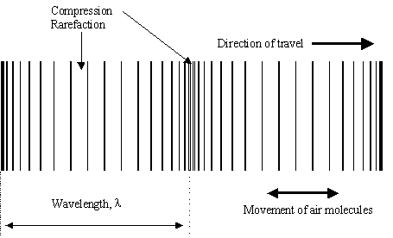
Figure 1 Type of Wave _________________________________________
2

1

1 _________________

2__________________

Figure 2 Type of Wave _________________________________________
3

3 __________________

4 __________________
4

Part 1 – Go to http://www.pbslearningmedia.org/resource/lsps07.sci.phys.energy.waves/what-is-a-wave/
- Click “Launch.” On the Introduction page, read and play each animation.
4) What is a wave?

- Read and play the animation on the Water Waves page. Watch the two dark blue circles.
5) What is this animation showing about the particles of a wave?

Part 2 – Go to http://www.acs.psu.edu/drussell/demos/waves/wavemotion.html. Study the pictures and read the information about each wave. Answer the questions below.
6) Describe how particles of matter move in a longitudinal wave.

7) Describe how particles of matter in a transverse wave move.

8) Describe how a longitudinal wave is different from a transverse wave.

9) Describe how particles of matter move in a water wave.

10) Describe how particles of matter move in a Rayleigh wave.

Part 3 - Go to http://www.pbslearningmedia.org/resource/phy03.sci.phys.mfw.spectrum/tour-the-electromagnetic-spectrum/ .
- Click “Launch” and then “Begin the Tour.”
- Read each page and hover over the pictures to find the information you need.
- Navigate to other pages by clicking “Next” or the words on the spectrum along the bottom of the screen
11) What type of wave on the electromagnetic (EM) spectrum is longer than the other types of waves on the spectrum?

12) List two other uses for microwaves besides heating up your food.
a.
b.

13) What is another name for the infrared waves section of the EM spectrum?

14) What is the prime example of a source for ultraviolet light?

15) Humans cannot see ultraviolet light. Are there any animals that are able to? What do they use it for?

16) What type of the EM spectrum would you want to use if thought you broke a bone?

17) What type of illness can X-ray radiation be used to treat?

18) How are gamma rays created?

